(The story will be on a single webpage with a white background)

**Header - Slo-mo looping video portrait of Yolanda with title and dek on top**

Section 1: Intro (No subhed)

* Short intro section with 150-250 words of text laying out what the story is about.
* This section will have two simple, but colorful bar charts showing that undocumented workers are more likely to get hurt and less likely to receive benefits than other workers

Example: All but one of the data viz elements in the story will be in this style.

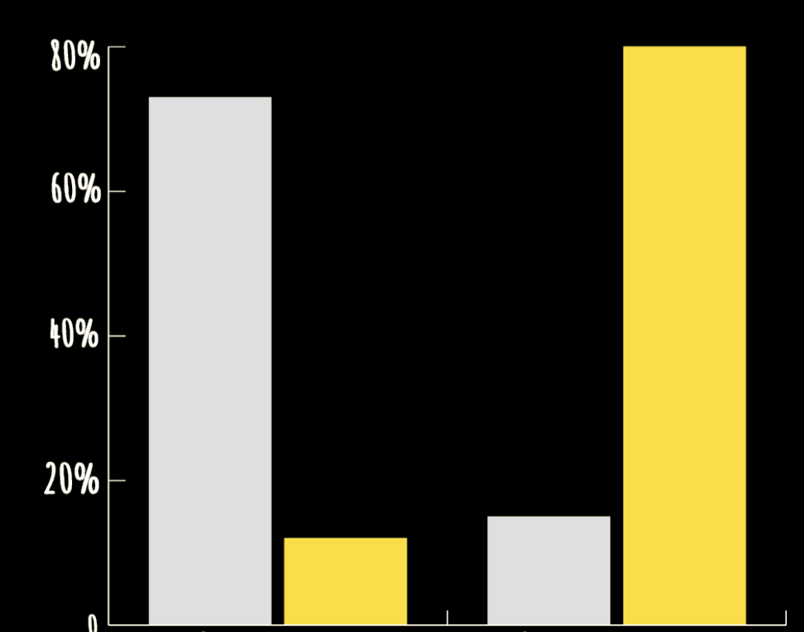

Section 2: **Yolanda Urioste: Hurt on the Job** (Subhed)

* The section opens with ~200 words giving background on Yolanda’s former job.
* Cell phone photo/photos of Yolanda working at her former job (provided by her)
* ~300 words of text
* 4 min video portrait of Yolanda comes onto the screen as you scroll down the page. The video auto-plays with the sound off and a prominent speaker symbol is present so readers can turn the sound off. Readers continue scrolling if they want to leave the video.
* ~100 words explaining Yolanda’s wage theft case. (A document with the details of her case is to the right side of the text and can be clicked to expand. Once open, the document with have important details highlighted.
* ~300 words of background text.
* Simple data viz (bar or pie chart) to illustrate some of the important statistics laid out in this section.
* ~100 words

Section break (full-screen photo of Yolanda that comes up with parallax scrolling to break up this section)

* ~300 words of text
* As your scrolling, a gallery fills the screen giving the readers the chance to click through and look at Yolanda’s medical records that bolster her claims. Important information is highlighted. (Inspiration: <http://projects.wsj.com/lobotomyfiles/?ch=one>)
* The rest of this section is ~1000 words periodically broken up with photos.

Section 3: **Lupe: Retaliation and stolen wages** (Subhed)

* Full-screen portrait photo of Lupe opens up this section
* ~750 words broken up with photos of Lupe and a pull quote.
* Data viz to give a more impactful illustration this statistic (Cal/OSHA currently staffs just one field inspector per 87,926 workers.)
* ~60 words

Section 4: **Abad: The most vulnerable, the day laborers** (Subhed)

* Full-screen looping video of Abad working to open the section.\
* ~250 words
* Portrait photo of Abad
* ~300 words
* 1.5 min video of Abad talking about why undocumented workers are reluctant to fight for better work conditions. (This is a smaller video in-line with the text that readers can click to start.)
* ~100 words
* Simple bar/pie chart
* ~100 words
* 1.5 min video of Abad talking about the kinds of injuries he sees among the day laborers he works with. (This video is in the same style as the previous one in this section.)
* ~100 words

Section 5: **Lorena Gonzalez: What can be done** (Subhed)

* This section opens with text
* ~500 words broken up with photos and one “talking-head” video of Lorena Gonzalez explaining how she’s trying to support undocumented workers